Against All Odds : The Unknown World of the Subaltern
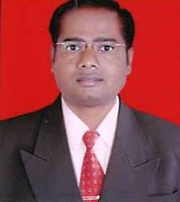
Suresh B. Deshmukh
Assistant Professor & Head,
Dept. of English,
Majalgaon College, Majalgaon,
Dist- Beed, MS, India

Abstract : Literature is one such a way to know the life of people that life is unknown to other. The writings of authors give us insight to read in between the lines, hear the unheard and unsaid. The contemporary literary theories help the reader to interpret and understand the various aspects of literary work. After the introduction of deconstructive theory in academy, the role of the critic is pivotal in making the statements about literary work. G.C. Spivak arouses many questions in relation to subaltern as woman. Her essay ‘Can the Subaltern Spivak?’ is responsible for propagating the term Subaltern in academic domain. For her, the woman is doubly marginalized and cannot be hard and interpreted. Today, the meaning of the term Subaltern has been widened to include the various oppressed, marginalized, exploited groups of society on account of class, caste, poverty and gender.
Keywords : Subaltern, Kolhati community, Jiji, Shanta, Susheela, Rambha, and Baby

